INFORMATION BOOKLET
Kearsley Public School
Individuals Achieving Goals Together

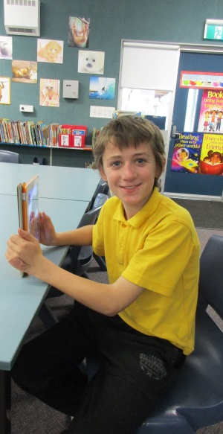
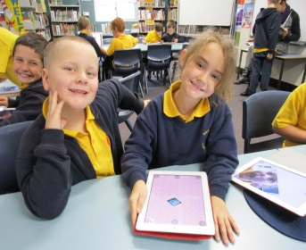
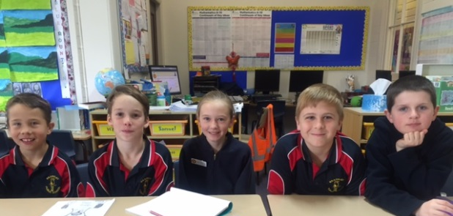

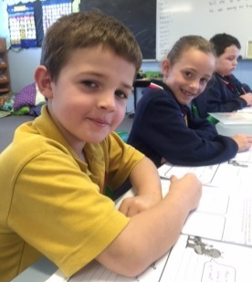

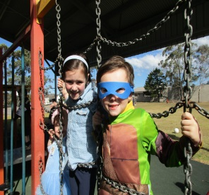

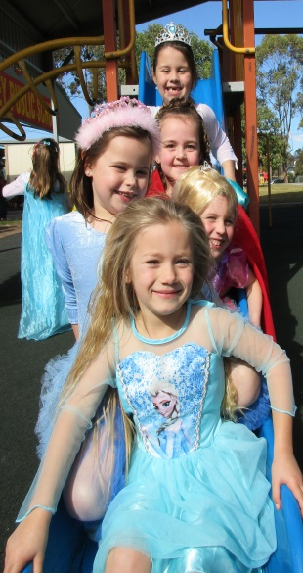
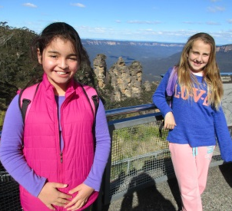

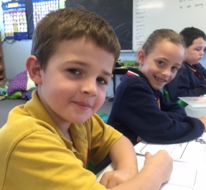

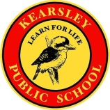

CONTENTS

- ANTI-BULLYING  - ASSEMBLIES  - ATTENDANCE  - AWARDS/REWARDS  - BANKING  - BOOK CLUB  - BUS PASSES/STUDENT TRANSPORT  - CANTEEN  - CAPTAINS  - CHILD PROTECTION  - COUNSELLOR  - COURT ORDERS  - CREATIVE AND PERFORMING ARTS  - ENROLMENTS  - EQUIPMENT  - EXCURSIONS / PERFORMANCES  - FACEBOOK  - FOOD  - GROUNDS  - HEALTH  - HIGH SCHOOL PLACEMENTS  - HOUSE/TEAM COMPETITIONS | - KULUWAYN ABORIGINAL EDUCATION TEAM  - LEARNING  - LIBRARY  - MONEY PAYMENTS  - NEWSLETTERS  - ORIENTATION PROGRAMS  - PARENT INVOLVEMENT  - PARENTS & CITIZENS ASSOCIATION  - POSITIVE BEHAVIOUR for LEARNING  - PERSONAL POSSESSIONS  - PLAYGROUND SUPERVISION  - SCHOOL FEES  - SCRIPTURE  - SPELLING MASTERY  - SPECIAL DAYS  - SPORT  - STUDENT REPRESENTATIVE COUNCIL  - STUDENT WELBEING AND DISCIPLINE  - WEBSITE  - UNIFORMS  - SCHOOL SONG and CREED

Kearsley Public School

130 Caledonia Street  Kearsley, NSW 2325  Phone: 49901705  Fax: 49911018 | Website: www.kearsley-p.schools.nsw.edu.au  School Email: kearsley-p.school@det.nsw.edu.au
Mission Statement

Kearsley Public School provides a stable, caring environment which promotes tolerance and encouragement. The well-presented school buildings and welcoming landscaped play areas are conducive to learning. "Individuals Achieving Goals Together".

Our School Purpose

The purpose of our school is to encourage all children to become active and successful participants in the community by providing them with the opportunity to learn and develop personally and socially through individualised support in a safe and enjoyable environment.

To achieve our purpose we will:

- Create a stimulating learning environment.  - Develop programs to meet the needs and interests of all students.  - Create a school climate which emphasises professional growth for all staff, collaboration in decision-making, collegiality, trust, and the pursuit of excellence. | - Encourage respect and pride.  Foster values which show concern for other people and the environment.  - Empower students to participate actively and responsibly in making decisions about their learning and their experience of school life.  - Stimulate active participation between the school and our community.

Principal: Mrs M. Trigg
Assistant Principal: Mr J. Folpp
Administration Manager: Mrs L. Weekes

Office Hours: 8:30am – 3:30pm

School Times

School Commences : 9:05am
Lunch: 11:05am – 11:55am
Recess: 2:00pm – 2:20pm
School Concludes 3:05pm

- Students should not be at school before 8:35am

ANTI-BULLYING

- Students at Kearsley Public School attend school to participate in a quality of education that provides them with skills and knowledge to contribute to the wider community.

- Each student has the right to feel safe and secure at all times within the school. Bullying will not be tolerated.

- Students, teachers and parents have a shared responsibility to create an environment that is conductive to learning and is free form bullying; allowing everyone to work and learn in a safe, secure environment.

ASSEMBLIES

Assemblies | - K-6 | - Fridays at 9am
 |  | Parent attendance welcomed
Special Assemblies | - End of Year | - Presentation Assembly

- Students are expected to sit still, pay attention, not talk, applaud when appropriate, sing the National Anthem and School Song enthusiastically and appropriately and to display good manners when receiving awards.

- Students are expected to enter and leave the assembly area quietly and orderly.

_

ATTENDANCE

- Regular attendance and punctuality at school are legal requirements.

- All attendance is monitored daily and poor attendance will be followed up with parents and possibly with the Home School Liaison Officer – in accordance with the policy of the Department of Education and Training.

- Written notes are required for all absences, clearly giving reasons.

- Doctor’s appointments should, wherever possible, be made out of school hours.

- Absences from school for a period of more than 15 days require permission from the Department of Education. Parents need to ask for the appropriate forms at the school office.

- All students should be in attendance at morning assembly at 9.05am.

- Students who are late and arrive after morning assembly must report to the school office for a late note. A record of lateness is kept.

- Early leave is only granted in exceptional circumstances. Early leave notes must be obtained from the school office. Notes must be given to the class teachers before a child leaves the school.

AWARDS and REWARDS
A system of awards is used to encourage positive and appropriate student behaviour, participation and achievement in all aspects of school life.

Awards include - PBL Award
- Kookaburra Award
- Principal’s Award
Rewards
- Term Reward for positive behaviour
- Reward Day for positive behaviour (end of year)

BANKING

- Students may open a school bank account with the Commonwealth Bank and bank at school every Thursday when deposit books are collected at morning assembly.

- Students are encouraged to bank regularly to develop life-long habits.

- Banking applications can be made at the school office.
_

BOOK CLUB
Order forms go home approximately once a term and parents may purchase suitable children’s books at reasonable prices.
_

BUS PASSES/STUDENT TRANSPORT
- Travel passes are available for all K - 2 children if required. However, once a child progresses to Year 3 they are only available if a child lives more than 1.6 kilometres from the school. Application are completed online – you can pick up a brochure from the office.

- Teachers and parents may, from time to time, need to transport students to events at other locations, eg: inter-school debates or public speaking competitions. In all cases, written permission will be sought from parents.

CANTEEN

- Follows the NSW Healthy School Canteen Strategy.
- Open each school day from 8.30am to 12.00pm.
- Lunch orders must be made before 9.05am.
- Ordered lunches are collected by class monitors at the beginning of lunchtime.
- Children may purchase snacks at lunchtime.
_

CAPTAINS

- School Captains and Vice-Captains are elected at the end of each year for the following year and the election results are announced at the Annual Presentation Assembly.

- A House Captain and Vice-Captain are elected at the beginning of each year from Year 6.

- School Captains, Vice Captains and Prefects are members of the Student Representative Council and perform a variety of duties throughout the year.

- House Captains and Vice Captains are responsible for organising their house teams at the various house carnivals and competitions.
_

CHILD PROTECTION

- A staged program of lessons on Child Protection is presented to K - 6 students each year. Participation by all students is encouraged.
- A permission note for these lessons is sent home at the beginning of each year.
_

COUNSELLOR
The school counsellor attends the school one day each fortnight and supports teaching, learning and welfare programs through educational testing, counselling, referrals and advice. The counsellor works with students, parents or carers and teachers in a variety of ways. The counsellor’s work includes:
  - counselling students
  - assisting parents or carers to make informed decisions about their child’s education
  - assessing students’ learning and behaviour
  - assisting schools to identify and address disabilities that affect students’ learning
  - liaising with other agencies concerned with the well-being of students.

School counsellors are members of the school’s student welfare and learning support team (LST). With the agreement of parents or carers, school counsellors will pass on to teachers information that will assist them to better meet the needs of their students.

Referrals to the counsellor may be initiated by the student, their parent or carer, or by their teacher. Where the parent or carer refers their child, additional information may be sought for the class teacher or LST.

School counselling is a confidential service and school counsellors will check with students, parents or carers before passing on information (such as the results of tests for learning difficulties) to others. This presumption of confidentiality can be overridden only by specific legal requirements (eg, child protection legislation) or where someone may suffer harm if information is withheld.
_

COURT ORDERS
The school must be informed immediately of any court orders relevant to any child enrolled at the school.
_

CREATIVE AND PERFORMING ARTS

Dance - The school has a dance group that usually participates in StarStruck each year.

Choir - The school choir also gives students the opportunity to perform on a variety of occasions at different venues.

Public Speaking - School competitions are held in which students can participate. Winners of the competition can compete at zone and regional levels. This competition continues to state and national levels.

Art / Craft - Various competitions are entered.

Debating - A debating team is formed with students from Years 5/6. They compete in the Premier’s Debating Challenge throughout the year.

Talent Quest - Held each year, late in Term 4.

ENROLMENTS

- Local enrolment areas (boundaries) exist for all public schools.

- Children living within the school’s boundaries should enrol in their local school.

- To enrol in Kindergarten, a child must turn five years of age on or before 31 July in the year of enrolment. A Birth Certificate or Passport must be shown as evidence of date of birth.

- Eligible students can be enrolled at any time.

- All information regarding enrolments can be obtained from the school office.

- Kindergarten orientation takes place in Term 4 each year.

EQUIPMENT
Exercise books will be provided by the school.

Stationery requirements will vary from class to class and grade to grade. The following is a general guide.

Years 5 - 6
blue/red ball point pens, HB lead pencils, coloured pencils, textas, scissors, glue stick, ruler, eraser, sharpener, homework book, pencil case, box of tissues

Years 3 - 4
HB lead pencils, coloured pencils, textas, scissors, glue stick, ruler, eraser, sharpener, homework book, pencil case, library bag, dictionary, box of tissues.

Years 1 - 2
HB lead pencils, coloured pencils, glue stick, ruler, eraser, sharpener, homework book, pencil case, library bag, box of tissues.

Kindergarten
coloured pencils, glue stick, pencil case, library bag, box of tissues.

- All items should (wherever possible) be clearly marked with the child’s name.

- Sports equipment can be borrowed at lunchtimes.

EXCURSIONS/PERFORMANCES
- A varied K - 6 excursions program operates throughout the year. Year 5/6 alternate between Canberra one year with Bathurst/Katoomba the following year, costing approximately $300.

- All children are expected to attend excursions and performances.

- Prices are kept to a minimum with generous discounts often offered. Financial assistance forms are available at the office – all requests are kept strictly confidential.

- Letters are sent home well in advance, providing all the relevant information.

- Payments are to be made in an envelope. Correct money is appreciated, but change will be given later via the eldest child, on the day of payment or the next day.

FACEBOOK
- Kearsley PS has a Facebook page with regular updates, photos and reminders.

FOOD
- Pack ‘little lunch’ (play lunch) and ‘big lunch’ (midday meal) separately. Make it as nutritious as possible. Children who eat nutritiously learn better. Breakfast is an essential meal for good concentration in class.
- No glass bottles or cans please
- Make sure that your child has sufficient food every day.
- No ‘lollies’ or soft drink please.
- Chewing gum is NOT ALLOWED at Kearsley PS.

GROUNDS
- Kearsley PS is a Non-Smoking Area.
- Dogs should not be brought onto the grounds at any time.
- The school grounds should not be entered outside of school hours, unless prior arrangement with the Principal.

HEALTH
Medicines and Drugs
- When children take prescribed medicines and drugs, the staff will assist ONLY if a written parent request is sent with the child.

- An Administration of Medication Form must be filled out and is available from the office. Please send the exact measure required by the child each day in ‘Webster’ packaging that can be organised at the chemist..

- All medicines must be taken to the office. No drugs or medicines to be kept in school bags. The exception to this rule is an appropriate asthma inhaler, if the student is identified as being an asthmatic.

Sick or Injured Children
When children are sick or injured, they are to tell their teacher or the teacher on playground duty or get someone to do this. Then, with the teacher’s knowledge, they report to the office for first aid. If medical attention seems to be required parents will be contacted and assistance may be sought if parents can’t be contacted.

Contagious Diseases - Children must stay away from school for the following conditions.

- Chicken pox At least five days after first spots appear or at least until blisters have all crusted.
- Conjunctivitis While there’s a discharge from the eye.
- Gastroenteritis/Vomiting At least 24 hours after diarrhoea or vomiting stops.
- German Measles Four days after rash appears.
- Hepatitis A Two weeks after first symptoms or one week after onset of jaundice.
- Impetigo Until treatment starts, sores should be covered by a watertight dressing.
(School Sores)
- Measles Five days after rash appears.
- Mumps Nine days after swelling occurs.
        - Head Lice Until the head is treated with anti-lice treatment from a chemist.
        - Hand,Foot & Mouth Until all blisters have dried. May return to school if sores are covered.
        - Whooping Cough 3 weeks from the onset of the whoop.

All the above rules are made by the NSW Health Department.

HIGH SCHOOL PLACEMENTS
- Parents can choose from a range of local and non-local high schools for their child to attend.

- An information evening is held at school prior to applications being made in Term 1.

- Students may sit the Selective Schools Test in Term 1, when in Year 6.

- Most high schools have open days for parents and students to attend early in the year and orientation days in late Term 4.

- Cessnock High School sends teachers and students to talk to Year 6 students about their school.

- Individual visits to high school with special programs or units can be arranged through the school counsellor.

HOUSE TEAM COMPETITIONS

There are four House Teams. On enrolment each child is placed in a House Team. Caledonia - Green
Allandale - Orange
Pokolbin - Blue
Tomalpin - White

Competitions, reflecting house names and colours, are held each year for: Swimming, Cross Country and Athletics.
The most successful House team each year wins the Champion House Trophy.

KULUWAYN ABORIGINAL EDUCATION TEAM

Aboriginal students have the opportunity to become a part of the Kuluwayn Education team. The President, Vice-President and Secretary are voted in by the team. They meet once a fortnight to discuss issues and make decisions relating to Aboriginal education at Kearsley PS.

LEARNING

Key Learning Areas

There are six Key Learning Areas.

- English - Talking / Listening, Reading, Writing
- Mathematics - Number, Patterns & Algebra, Data, Measurement, Space & Geometry, Working Mathematically
- History and Geography
- Science and Technology
- Creative and Practical Arts (CAPA)
- Personal Development / Health / Physical Education (PDHPE)

- The syllabuses for the Key Learning Areas work students through Stages: Early Stage 1, Stages 1, 2 and 3.

- Students work towards achieving Learning Outcomes appropriate to their ability and age/stage of development.

- Most children will achieve the outcomes for the Stages as follows
Early Stage 1 - Kindergarten, Stage 1 - Years 1 & 2, Stage 2 - Years 3 & 4, Stage 3 - Years 5 & 6

Assessment and Reporting

- Assessments are made at individual, class, grade, school and state levels.

- Written reports are provided at the end of Terms 2 and 4.

- Parent/teacher interviews are encouraged, scheduled at set times and available by appointment at any time.

Best Start
- The Best Start Kindergarten Assessment is designed to identify each student’s literacy and numeracy skills and understanding at the beginning of Kindergarten.
- Best Start is inclusive: All children have the opportunity to participate. Teachers of students with confirmed disabilities and/or special needs are additionally supported in building a profile that informs quality teaching and learning programs for these students.
National Assessment Program Literacy and Numeracy (NAPLAN)
- National Literacy and Numeracy Tests will occur in Term 2 for students in Years 3 and Year 5.
- Parents will receive written reports and be able to discuss the results with the relevant teachers.

Homework

Homework is valuable because it provides opportunities for students to revise and consolidate concepts taught, explore ideas and challenge themselves and their learning. You can expect homework to be appropriate for each student’s age and ability, set and marked accordingly and for students to be given feedback.

While homework is an important component of education, schools recognize that it is important for students to have time for play, leisure and physical activities outside of school.

Technology

Our computer network and technology are constantly being upgraded. The new computer laboratory and interactive whiteboards provide a significant learning platform for students, with internet access and the school intranet. All classes have computers and an interactive whiteboard. The school Library operates as an information centre. Use of the digital video and still cameras has been incorporated into student work. Both short and long term technology plans have been developed to ensure that Kearsley PS is providing every opportunity for its students to be computer and technologically literate.

Learning Support

Specialist staff provide support to students including:

  - Support Teacher Learning Assistance (STLA)
  - Teacher/Librarian
  - School Learning Support Officer (SLSO)

LIBRARY
Our school Librarian attends school one day each week. Children may borrow books each week if they have a library bag. Lost or damaged books must be paid for. The Library is an information centre, with computer access. Each year our school celebrates Book Week with a Book Fair and a Book Parade where students dress as their favourite character.

MONEY PAYMENTS
- Money payments can be for excursions, work books, PSSA sport, visiting performances, discos, concerts, special programs, class activities or fundraising.
- Notes will be sent home with details of events.
- All payments must be made with the child’s name and class clearly labelled.
- Early payments are encouraged.
- Change can be returned to the child from the office, once the payment has been received and receipted by the front office. The change will be returned to the child in an envelope via their teacher but exact payment is preferred.
- For large payments, such as camp fees or work book fees, arrangements can be made with the Principal to pay off the amount over time.
- If you are experiencing financial difficulties Student Assistance forms are available at the office. These applications are kept strictly confidential.

_

NEWSLETTERS
Newsletters are published fortnightly on a Thursday and placed on our website. They are distributed to the oldest child in each family at the school so please look out for it in your child’s schoolbag. Newsletters contain important information about what’s happening at school.

_

ORIENTATION PROGRAMS
Kindergarten Orientation - Students and parents are invited to attend on five occasions to build familiarity with the school during Term 4.
_

PARENT INVOLVEMENT
The following suggestions for parents can help the school, your children, their education and you:
- Communicate regularly with teachers and staff.
- Read the weekly Newsletter.
- Set up good routines for your children, such as:
- doing homework
- getting ready for school and being on time
- wearing proper school uniform
- going to bed
- daily reading
- bringing home notes
- Talk positively to your children about their school, schoolwork, teachers and education.
- Make money payments on time, with permission notes included.
- Ensure that your child’s clothes and possessions are all clearly labelled.

PARENTS & CITIZENS ASSOCIATION
- The P & C meets at 1:30pm, on the first Thursday of each month to discuss what’s happening at the school, to organise fundraising activities, run the canteen and discuss educational issues.

- The P & C runs the canteen and assistance is always welcome.

- Meetings are advertised in the newsletter, on the website and on notices around the school.

________________________________________________________________________________________

POSITIVE BEHAVIOUR for LEARNING (PBL)

Kearsley PS is a PBL school. Our school has 3 core values – Respect, Responsibility and Learning. Lessons occur each week to teach about the core values. Each term students work towards ‘reward’ days for positive behaviour.
________________________________________________________________________________________

PERSONAL POSSESSIONS
Students must take responsibility for their own possessions.

- Items NOT to be brought to school include: iPods, hand-held games, large toys, valuable toys, knives or weapons of any kind, water pistols, water bombs, chewing gum, scooters and make up

- Labels - All clothing, school bags, lunch boxes, drink bottles and all removable items should be clearly labelled with child’s name and class. Clearly marked items are easily able to be returned. SO PLEASE CLEARLY MARK ALL ITEMS.

- Jewellery - Should not be worn at school, except for studs if a child has pierced ears. The school cannot be responsible for the loss of expensive jewellery. Dangling earrings should not be worn, as accidents can occur.

- Mobile phones - Students are to leave mobile phones at home as they may always use the school phone to contact parents if needed.

_
PLAYGROUND SUPERVISION
Supervision Times
Morning - No supervision before 8.35 am
- From 8.35 am, students may play in the morning assembly area only
- All other areas are out of bounds
- Running, kicking, throwing or big ball games are not allowed
- Fixed Equipment is NOT to be used
- Handball is allowed
- Teacher supervision of playground from 8.35 – 9.05 am

Lunch - There is a Teacher and a Student Learning Support Officer (SLSO) on the playground
and Recess during lunch and recess.

After School - Students are to go straight home unless waiting for parents or participating in school events. Running, kicking, throwing or big ball games are not allowed and the fixed equipment is NOT to be used.
- Students catching the bus are to sit in bus lines. They will be supervised by a staff member.

_______________________________________________________
SCHOOL FEES

Voluntary school contributions are $30 for families with 1 student, $50 for families with 2 students, $60 for families with 3 or more students. These fees are not compulsory, but are much appreciated as they are put towards purchasing much needed supplies and equipment used daily by the students at our school.

_______________________________________________________________________________________
SCRIPTURE
Half an hour is set aside each Tuesday for scripture lessons by religious groups for Infants classes. Children who do not attend scripture continue normal lessons in their classrooms. Parents decide on scripture classes. A note is required if parents wish to make a change.

SPECIAL DAYS

Each year our school celebrates a range of special events. We hold a Mother’s Day morning/afternoon tea, Father’s Day/Blokes Breakfast as well as Grandparents Day. Our P&C hold Mother’s Day and Father’s Day stalls where our students can purchase gifts for a small cost.

_________________________________________________________________________________________

SPELLING MASTERY

Children from Years 1- 6 participate in spelling groups 4 mornings a week. Each child is tested and placed in a spelling group at the beginning of the year. Spelling tests occur every 5 lessons. A homework sheet for spelling groups is sent home every 5 lessons as well.

_________________________________________________________________________________________

SPORT

The school competes in Swimming, Athletics and Cross Country carnivals.
- School Sport - held on Fridays for K-6

- A variety of sporting teams are selected to represent the school throughout the year. These sports include soccer, basketball and OzTag.

- Fitness programs support our other sporting programs.

_

STUDENT REPRESENTATIVE COUNCIL
- The SRC is a group of students in the school, elected by and from their fellow students, to represent them in the school and organise ways for them to participate in the school.

- Our SRC is made up of our School Captains and Vice Captains. There are also two representatives from each grade, Years 2 - 6.

- The SRC is educational, democratic, responsible, sharing, caring, fun and rewarding.
_

STUDENT WELFARE AND DISCIPLINE
Kearsley PS has comprehensive student welfare and discipline programs and policies. For complete details, see the ‘Student Welfare and Discipline Booklet’.

WEBSITE
Our school website contains copies of the Annual School Report, the School Management Plan, this Information Booklet, the Student Welfare and Discipline Booklet, the Anti-Bullying Policy, the canteen price list, copies of newsletters, the school’s yearly calendars and updates about activities at the school.

UNIFORMS
Summer
To be worn Monday - Thursday

GIRLS BOYS
- Navy, Red and Gold polo with school logo • Navy, Red and Gold polo with school logo
- Navy culottes or shorts • Navy blue shorts
- Black shoes • Black shoes
- White socks • White socks
** The School polo shirts are available from the school office, on behalf of the P&C**

If cold – blue track suit top
BOYS AND GIRLS
Winter Sports Uniform
To be worn Monday - Thursday To be worn on Friday

- Navy blue tracksuit
- Navy, Red and Gold polo with school logo • Navy, Red and Gold polo with school logo
- School hat • Navy Shorts
- Black shoes • Sport shoes
- Navy socks • White socks

**A navy broad brimmed hat is essential and can be purchased from the school - $12**

Our School is proud of its uniform and all students are encouraged to wear it at all times.

A clothing pool is available at the office

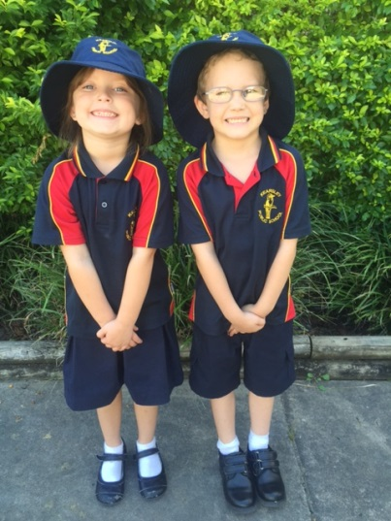
Uniform components are available from:

- The School Office (polo shirts only)
- John Flanagan Menswear
92 Vincent Street
CESSNOCK
Phone; 49906388

School Song

We are the students of Kearsley School
We work then play and try our hardest.
We want to learn every single day,
And responsibility is our quest.
Red and gold are the colours we love.
We proudly wear them for all to see.
We show respect at Kearsley School
In everything we say and do.

School Creed

This is our school
We remember our motto:
“Learn for Life’

We try to listen,
Share,
And do our best work.

We always show respect
To all adults
and to each other.

All these things and more,
We can
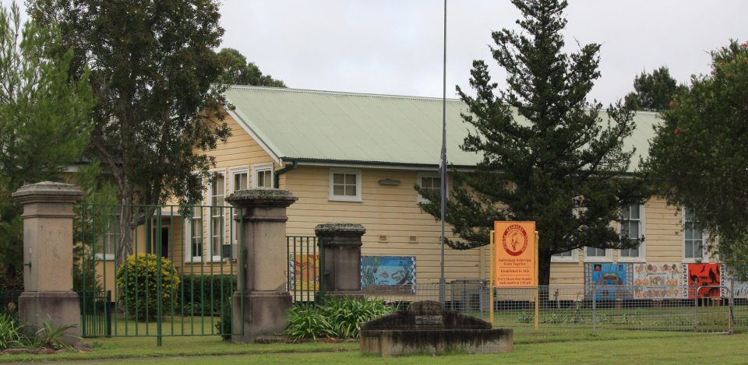
“Learn for Life”

