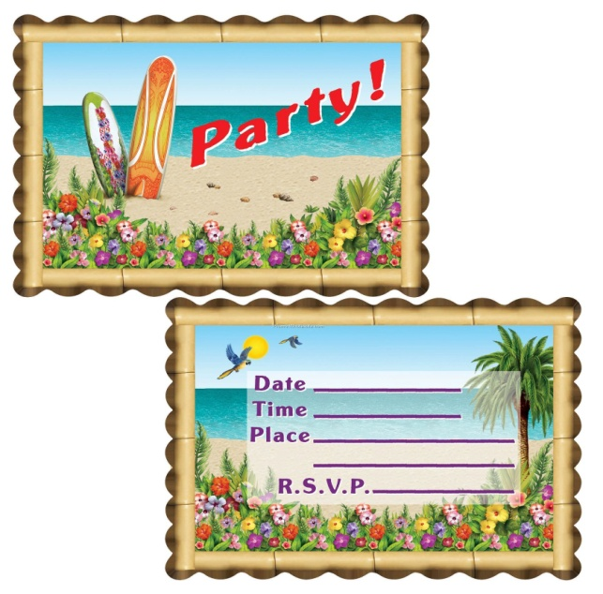

**All students K – 6 are invited to the**

**Year 6 Farewell Disco**

**When:** Monday 28th November 2011

**Where:** Kearsley Community Hall

**Time:** 7pm – 9pm

**Cost:** $3 per student

Drinks, Chips & Glow sticks will be available for purchase.

**PLEASE NOTE:** The disco is for KPS students **only** and will be fully supervised by the staff.

**All students to be collected**

**promptly at 9pm.**

**All students K – 6 are invited to the**

**Year 6 Farewell Disco**

**When:** Monday 28th November 2011

**Where:** Kearsley Community Hall

**Time:** 7pm – 9pm

**Cost:** $3 per student

Drinks, Chips & Glow sticks will be available for purchase.

**PLEASE NOTE:** The disco is for KPS students **only** and will be fully supervised by the staff.

**All students to be collected**

**promptly at 9pm.**